Part Number: PT936-4712V-XX
PT936-4713V-XX

Kit Contents
Item # | Quantity Reqd. | Description
1 | 1 | Front Driver Door Guard (Reference Pink Sticker)
2 | 1 | Front Passenger Door Guard  (Reference Blue Sticker)
3 | 1 | Rear Driver Door Guard (Reference Green Sticker)
4 | 1 | Rear Passenger Door Guard (Reference Yellow Sticker)
Hardware Bag Contents
Item # | Quantity Reqd. | Description
1 | N/A
2
Additional Items Required For Installation
Item # | Quantity Reqd. | Description
1 | A/R | Simple Green All-Purpose Cleaner – Full Strength
2 | A/R | Lint-free towel
3 | A/R | Blue painter’s masking tape
4 | 1 | Scissors
Conflicts
None
Recommended Tools
Personal & Vehicle Protection | Notes
None
Special Tools | Notes
PPO Magnetic Template | IADS p/n =  PRV12-D5-01
DIO Paper Door Templates | See last page of these  instructions
Nylon Removal Tool(NRT) | SST p/n =  00002-06002-01
Installation Tools | Notes
12-oz. rubber mallet | IADS p/n =PRI10-D5-02  Vaughn, p/n = SF12
Special Chemicals | Notes
None
General Applicability
All

Recommended Sequence of Application
Item # | Accessory
1 | Body Side Molding
2 | Door Edge Guard
*Mandatory
Vehicle Service Parts (may be required for reassembly)
Item # | Quantity Reqd. | Description
1
2
3
Legend
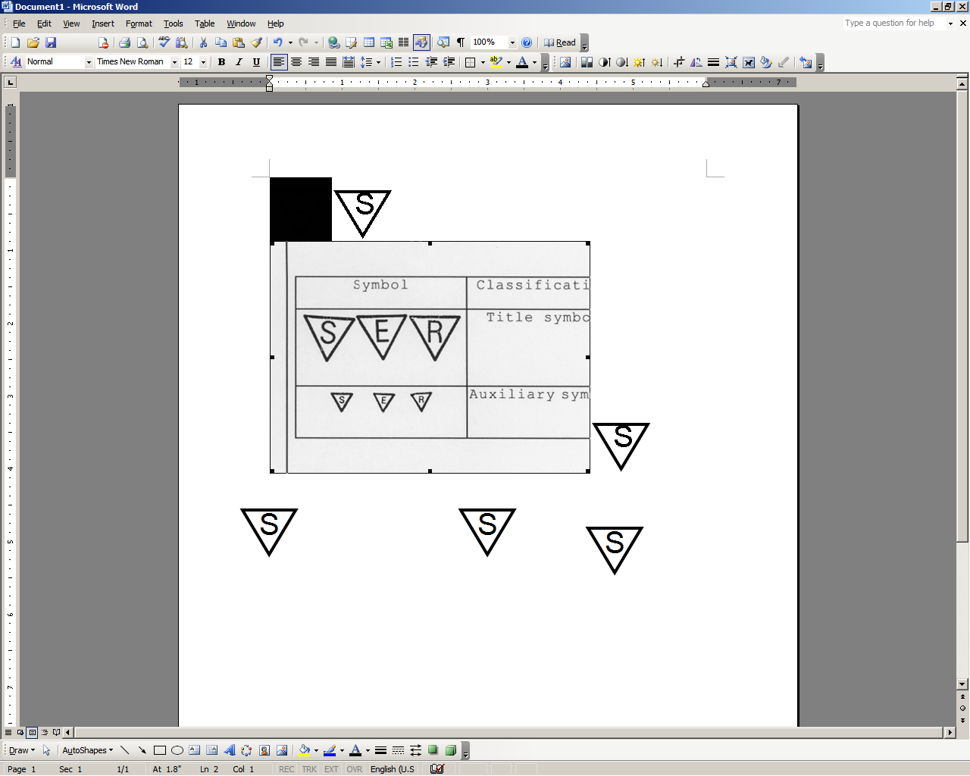




STOP: Damage to the vehicle may occur. Do not proceed until process has been complied with.
OPERATOR SAFETY: Use caution to avoid risk of injury.
CAUTION: A process that must be carefully observed in order to reduce the risk of damage to the accessory/vehicle and to ensure a quality installation.
TOOLS & EQUIPMENT: Used in Figures calls out the specific tools and equipment recommended for this process.
REVISION MARK: This mark highlights a change in installation with respect to previous issue.

SAFETY TORQUE: This mark indicates that torque is related to safety.

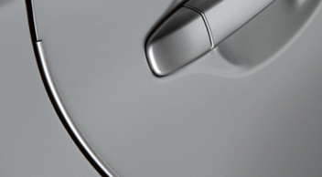

Care must be taken when installing this accessory to ensure damage does not occur to the vehicle.
The installation of this accessory should follow approved guidelines to ensure a quality installation.

These guidelines can be found in the "Accessory Installation Practices" document.

This document covers such items as:-
- Vehicle Protection (use of covers and blankets, cleaning chemicals, etc.).
- Safety (eye protection, rechecking torque procedure, etc.).
- Vehicle Disassembly/Reassembly (panel removal, part storage, etc.).
- Electrical Component Disassembly/Reassembly (battery disconnection, connector removal, etc.).

Please see your Toyota dealer for a copy of this document.
- Rear Door Edge Guard (DEG)

Trailing Edge
  - Preparation of Surface(s)
NOTE: It is critical to this installation that car door edges are completely free of wax and oil residue to permit the DEG to engage and grip the door’s edge. The key goal for preparation is to ensure complete removal of residue that can prevent the DEG from gripping. Please follow the steps in their entirety.

- Fully open rear driver door.

- Using 2 (two) lint free cloths:
    - Spray 3~4 pumps of Simple Green (or VDC approved cleaner) onto lint free towel and pinch the wet towel between your thumb and forefinger while running along the length of the door edge to clean the inside and outside of the trailing edge of door. Make several passes to ensure the wax and oil has been removed. (Fig. 1-1)

Fig. 1-1
    - Using the second lint free cloth, thoroughly dry the area free of Simple Green cleaner previously applied. In some instances a rubber weather seal may be found – ensure to clean between the trailing edge and rubber seal. (Fig. 1-2) Turn the cloth repeatedly to attain a dry surface. NOTE: When correctly cleaned, resistance will be felt on the lint free towel during the drying process.
Fig. 1-2
- Repeat Step (2), if resistance is NOT felt.

Installation of Rear Door Edge Guard (DEG)
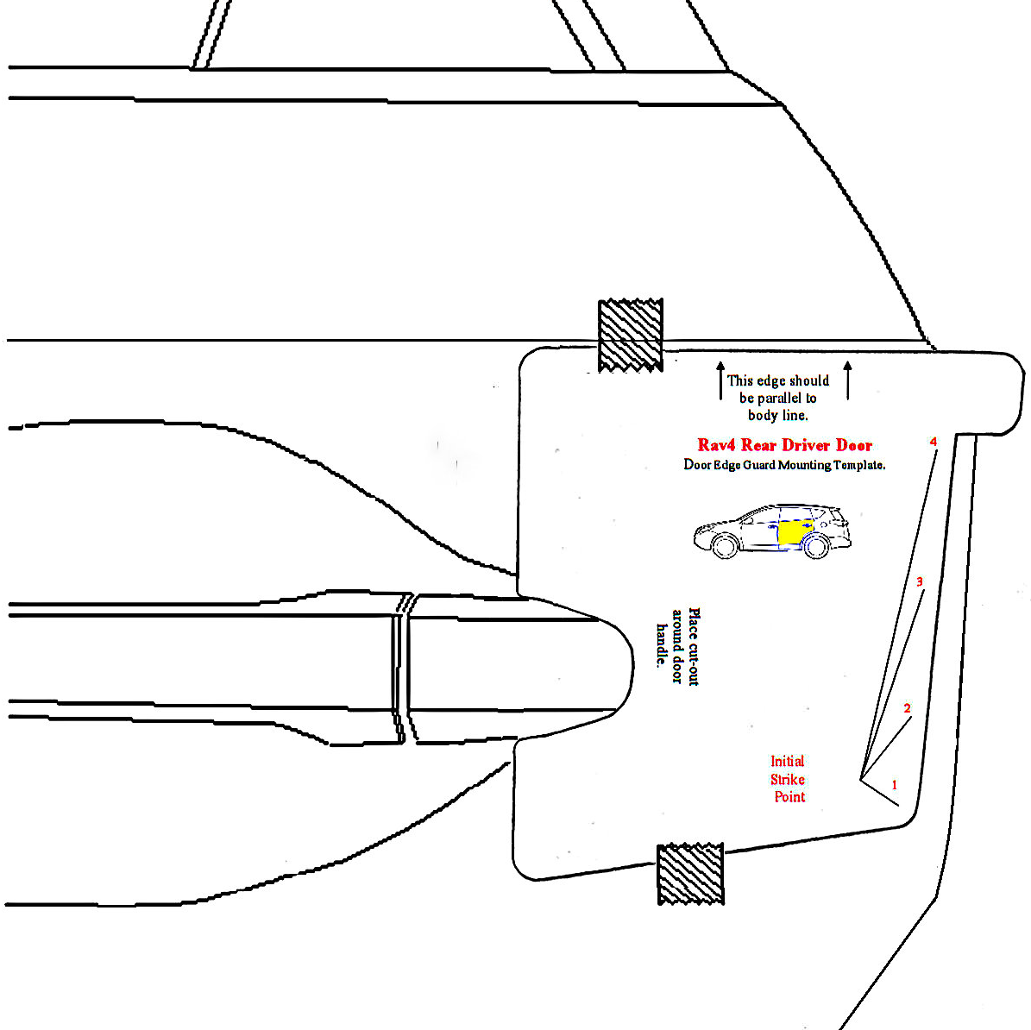

NOTE: If being installed at Port, all references to “template” refer to a magnetic template. If being installed by a dealer or individual, all references are to the paper templates located on the last page of these instructions.
Parallel to
Body line
  - If you will be using the paper templates; use scissors and carefully cut them out at this time.
NOTE: Magnetic templates are reversible for use on both sides of the vehicle.
  - Select rear door template and fit notch around door handle. Adjust as needed to ensure it is parallel to body line directly above the template. If needed, tape into place using painter’s masking tape. (Fig 1-3)
Fig. 1-3
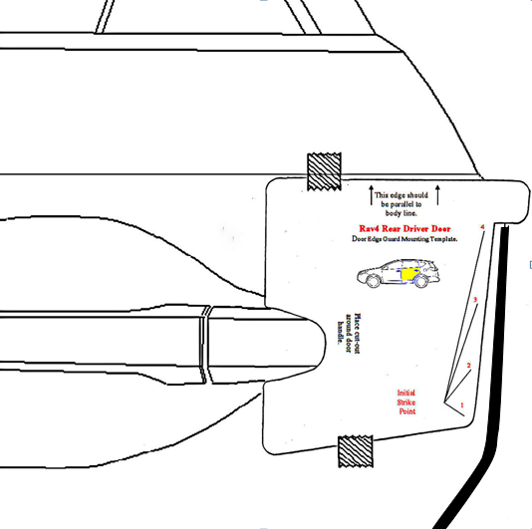
  - Align top edge of the DEG, (labeled Rear Driver with Green sticker), with lower edge of template alignment notch as shown.
NOTE: Top of DEG can be identified by matching the profile of DEG to the door profile. (Fig 1-4)
NOTE: In some instances, the free form shape of the DEG may differ from exact physical door contours. Production tooling consideration for the DEG provides the channel with ‘memory’ to conform to the exact door contours as the channel is installed.
Fig. 1-4
NOTE: BEFORE PROCEEDING IT IS EXTREMLY IMPORTANT TO PROPERLY ALIGN THE DOOR EDGE, DOOR EDGE GUARD CHANNEL AND MALLET AS SHOWN IN FIG. 1-5. MALLET TECHNIQUE IS VITAL FOR PROPER INSTALLATION:
Fig. 1-5
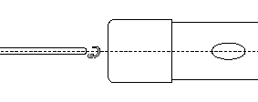
Outside of door

Rubber Mallet
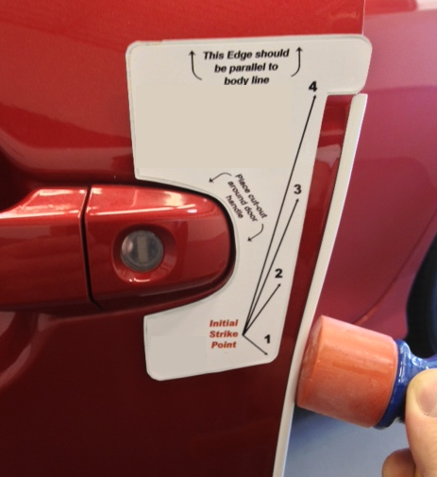
  - Mallet blows need to be delivered squarely (broad face contact opposed to point contact) to the spine of the molding, and perpendicular to the door edge as shown. While holding DEG in proper alignment with one hand, use soft side of the rubber mallet to begin tapping the channel onto the door edge, starting at Striking Point #1 on the template (~3” inches below the top of the DEG). Ensure the channel is fully engaged onto the door edge before proceeding to the next step. (Fig. 1-6)
Fig. 1-6
NOTE: If DEG needs to be removed for any reason, the DEG should be replaced with a new part. (DEG employs compression fit design for retention and appropriate retention cannot be assured if DEG is reinstalled).
Nylon Removal Tool and
Rubber Mallet

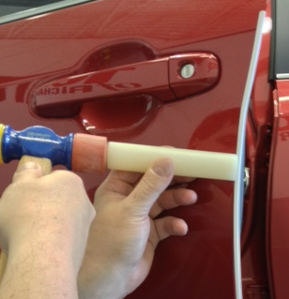
CAUTION: DO NOT PULL ON THE DEG; THIS CAN DAMAGE THE DEG AND THE FINISHED PAINT QUALITY.
Follow DEG removal procedure described in NOTE below:
NOTE: Recommended removal technique is with use of a Nylon Removal Tool (NRT). Begin by positioning the tip of the NRT against the leading edge of the DEG on the outside face of the door. Gently tap the NRT just below the top of the DEG to begin disengaging the DEG, and tapping progressively down the length of the channel until about 3” from the bottom. Finish removal tapping from bottom of DEG working up, catching DEG as it comes off the door. (Fig. 1-7)
Rubber Mallet
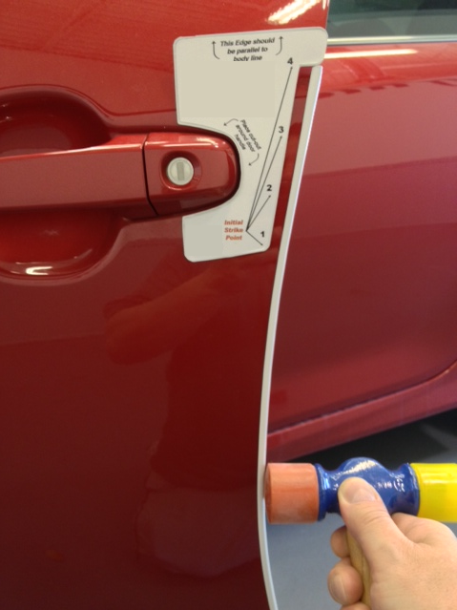
Fig. 1-7

  - Continue tapping channel onto door edge moving toward the top of door before proceeding down the entire length of the DEG. Use your other hand to steady and guide DEG as you go. (Fig.1-8)

Fig. 1-8
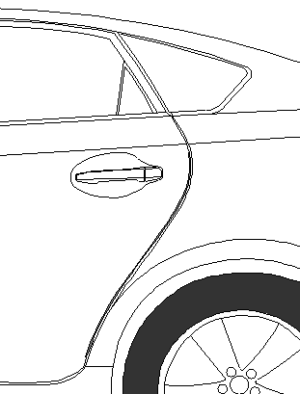
NOTE: IT IS IMPORTANT TO FULLY ENGAGE THE CHANNEL ONTO THE DOOR EDGE AT EACH POINT BEFORE YOU PROCEED DOWN AND AROUND THE CURVES OF THE DOOR.

  - With DEG engaged along its full length; begin again at the top of the DEG, progressively tapping with moderate blows (use soft side of mallet) down entire length to ensure channel is fully seated.
  - Carefully use firmer side of mallet to very lightly tap down the length of the DEG. If fully seated you should hear a solid report from the tapping.
Fig. 1-9
NOTE: Intended purpose of this step is to listen for a solid report in response to light taps to confirm DEG is fully seated. THE FIRMER SIDE OF THE MALLET CAN DAMAGE THE DEG IF USED WITH MODERATE OR HEAVY BLOWS. If audible report received with light tap indicates DEG is not fully seated, repeat steps 1(vi) and 1(vii).
  - Carefully close rear door and visually ensure DEG has sufficient clearance from adjoining body panels. Carefully remove template from door and retain for use on passenger side. (Fig. 1-9)

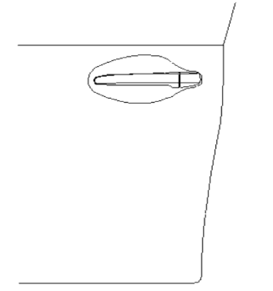
Front Door Edge Guard (DEG)
Fig. 2-1
Trailing Edge

Preparation of Surface(s)
NOTE: It is critical to this installation that car door edges are completely free of wax and oil residue to permit the DEG to engage and grip the door’s edge. The key goal for preparation is to ensure complete removal of residue that can prevent the DEG from gripping. Please follow the steps in their entirety.
- Fully open front driver door.
- Using 2 (two) lint free cloths:
    - Spray 3~4 pumps of Simple Green (or VDC approved cleaner) onto lint free towel and pinch the wet towel between your thumb and forefinger while running along the length of the door edge to clean the inside and outside of the trailing edge of door. Make several passes to ensure the wax and oil has been removed. (Fig. 2-1)
Fig. 2-2

    - Using the second lint free cloth, thoroughly dry the area free of Simple Green cleaner previously applied. In some instances a rubber weather seal may be found – ensure to clean between the trailing edge and rubber seal. (Fig. 2-2) Turn the cloth repeatedly to attain a dry surface. NOTE: When correctly cleaned, resistance will be felt on the lint free towel during the drying process.
- Repeat Step (2), if resistance is NOT felt.

  - Installation of Front Door Edge Guard (DEG)

Parallel to
Body line

  - Select front door template and fit notch around door handle. Adjust as needed to ensure it is parallel to body line directly above the template. If needed, tape into place using painter’s masking tape. (Fig 2-3)

Fig. 2-3

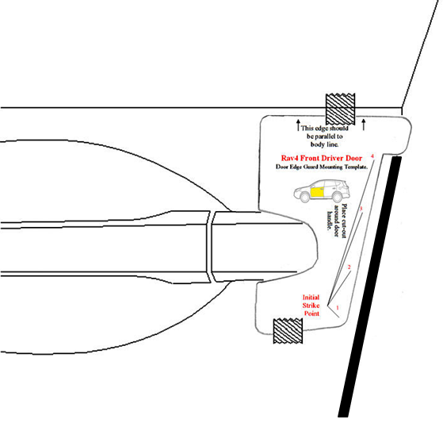
  - Align top edge of DEG (labeled Front Driver with Pink sticker) with lower edge of template alignment notch as shown. (Fig 2-4)

Fig. 2-4

  - While holding DEG in proper alignment with one hand, use soft side of the rubber mallet to begin tapping the channel onto the door edge starting at Striking Point #1 (~3” inches below the top of the DEG), working your way to the top of the DEG. (Fig 2-5) Ensure top of DEG is fully engaged on the door edge before proceeding to next step.
Rubber Mallet

NOTE: If DEG needs to be removed for any reason, the DEG should be replaced with a new part. (DEG employs compression fit design for retention and appropriate retention cannot be assured if DEG is reinstalled).
Fig. 2-5

CAUTION: DO NOT PULL ON THE DEG; THIS CAN DAMAGE THE DEG AND THE FINISHED PAINT QUALITY.
Nylon Removal Tool and
Rubber Mallet
Follow DEG removal procedure described in NOTE below:
NOTE: Recommended removal technique is with use of a Nylon Removal Tool (NRT). Begin by positioning the tip of the NRT against the leading edge of the DEG on the outside face of the door. Gently tap the NRT just below the top of the DEG to begin disengaging the DEG, and tapping progressively down the length of the channel until about 3” from the bottom. Finish removal from bottom of DEG working up, catching DEG as it comes off the door. (Fig. 2-6)
Fig. 2-6
Rubber Mallet

  - Continue progressively tapping channel onto door edge proceeding down the entire length of the DEG. Use your other hand to steady and guide the DEG as you go. (Fig. 2-7)
NOTE: IT IS IMPORTANT TO FULLY ENGAGE THE CHANNEL ONTO THE DOOR EDGE BEFORE YOU PROCEED DOWN AND AROUND THE CURVES OF THE DOOR.
  - With DEG engaged along its full length: begin again at the top of the DEG progressively tapping with moderate blows (use soft side of mallet) down entire length to ensure channel is fully seated.
Fig. 2-7
  - Carefully use the firmer side of mallet to very lightly tap down the length of the DEG. If fully seated you should hear a solid report from the tapping.
NOTE: Intended purpose of this step is to listen for a solid report in response to light taps to confirm DEG is full seated. THE FIRMER SIDE OF THE MALLET CAN DAMAGE THE DEG IF USED WITH MODERATE OR HEAVY BLOWS. If audible report received with light tap indicates DEG is not fully seated, repeat steps 2(v) and 2(vi).
  - Carefully close front door and visually ensure DEG has sufficient clearance from adjoining body panels. Carefully remove template from door and retain for use on passenger side. (Fig. 2-8)
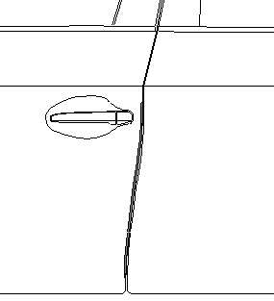
Fig. 2-8

Repeat steps 1, and 2 on the passenger side of vehicle.

Accessory Function Checks
Confirm all Door Edge Guards are fully seated

Vehicle Function Checks

Vehicle door operation

Vehicle Appearance Check

After accessory installation and removal of protective cover(s), perform a visual inspection.

Look for a fairly consistent gap between the DEG and adjoining vehicle panels.

NOTE: Normal vehicle manufacturing tolerances may exist that are not a consequence of an improperly seated DEG installation.

Confirm all four vehicle doors open and close without interference from DEG or Body Side Molding.

Ensure no damage (including scuffs and scratches) was caused during the installation process. (For PPO installations, refer to TMS Accessory Quality Shipping Standard.)

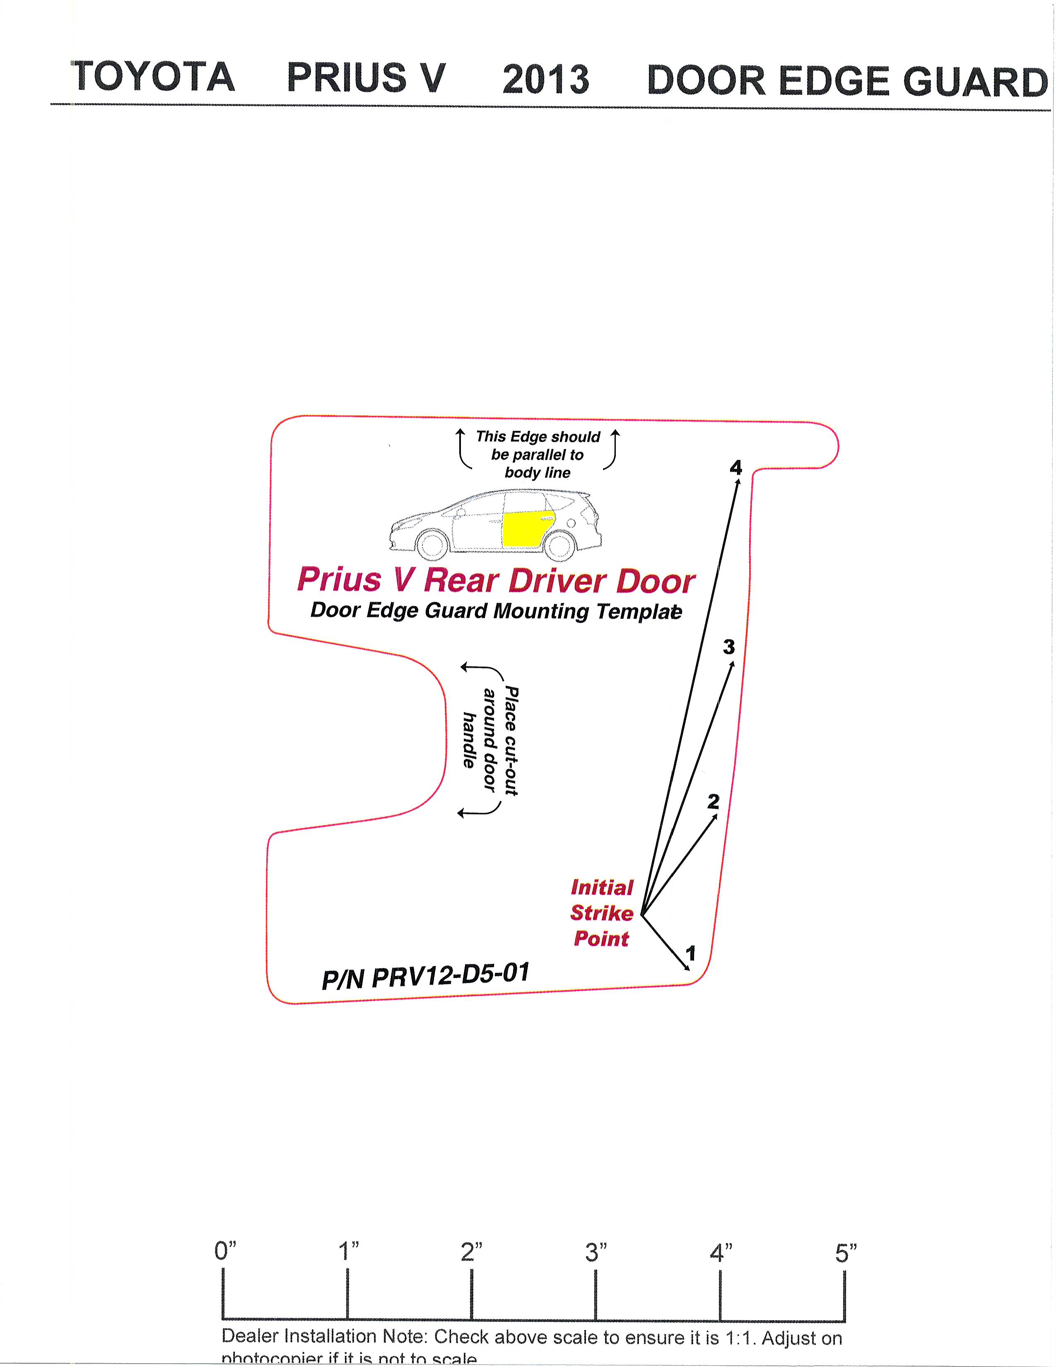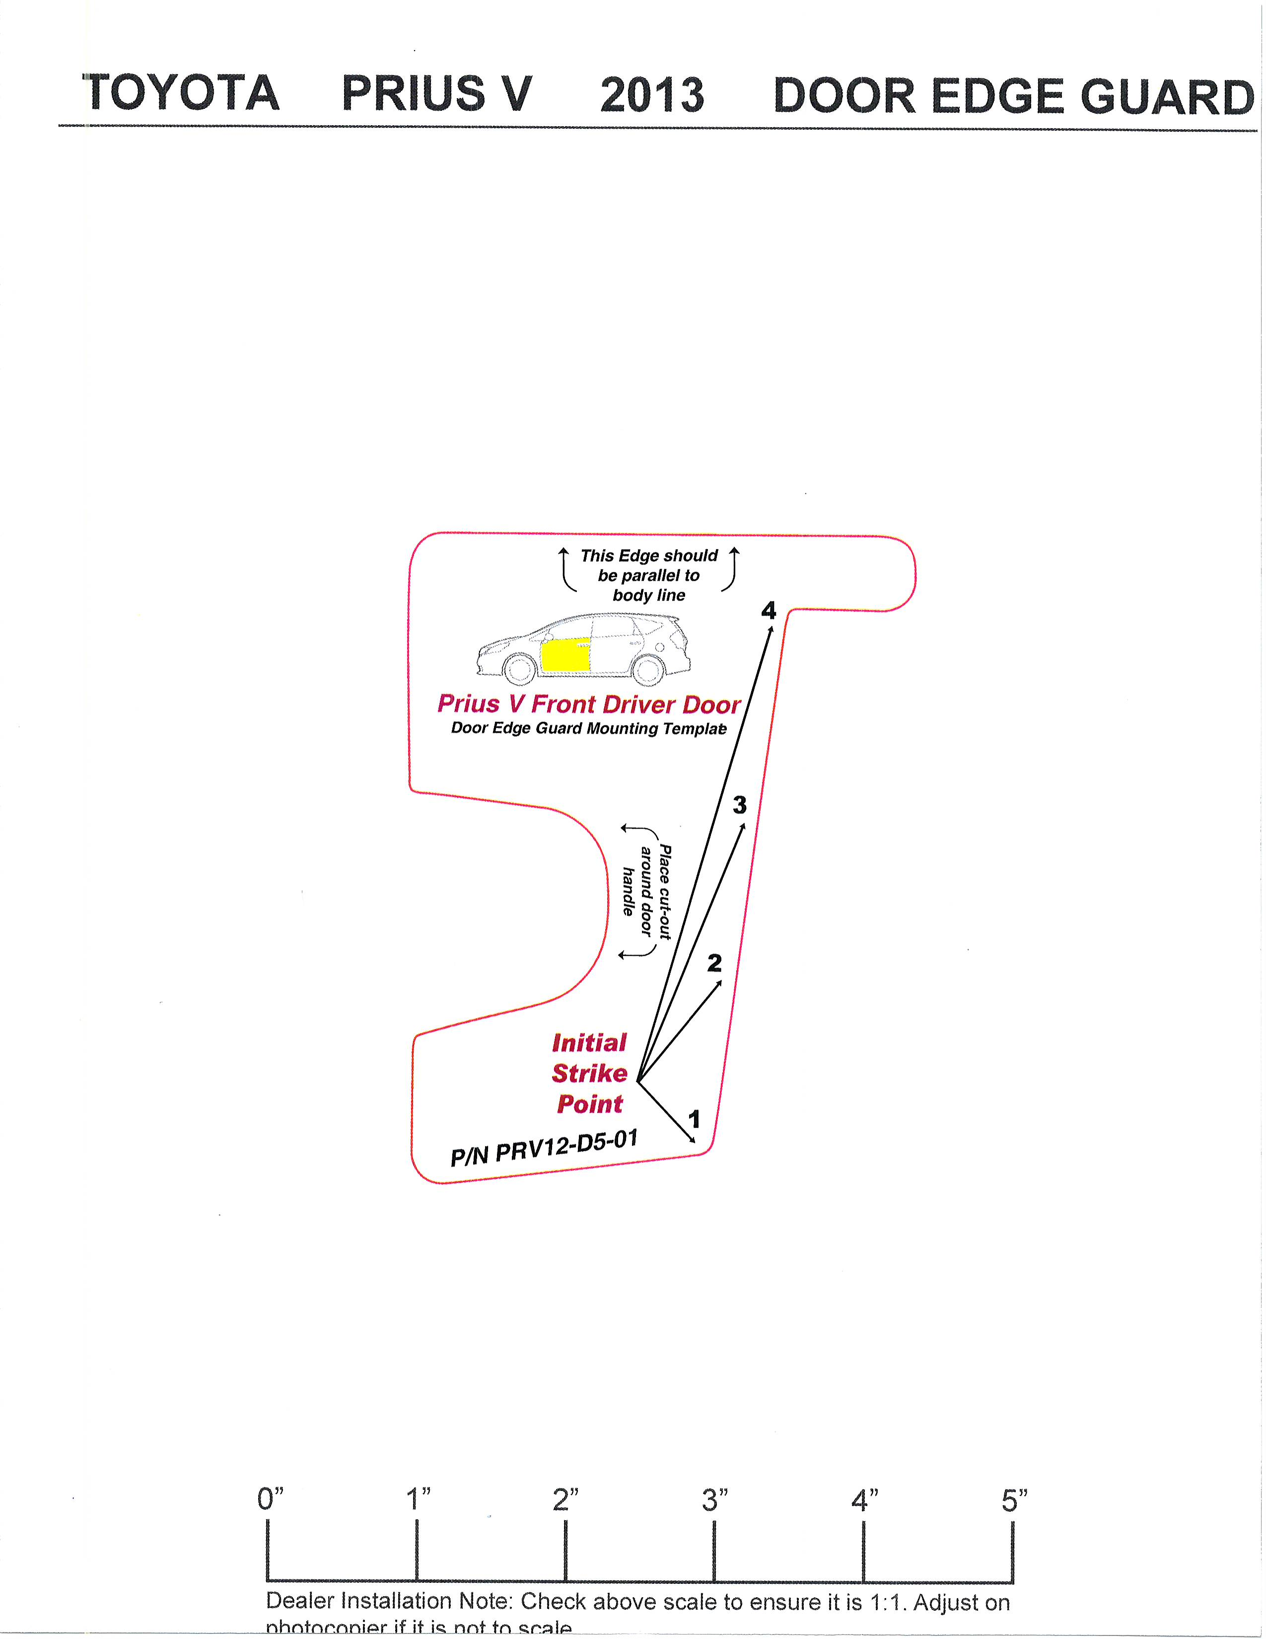
0”
1”
2”
3”
4”
5”
Dealer Installation Note: Check above scale to ensure it is 1:1. Adjust on
photocopier if it is not to scale.

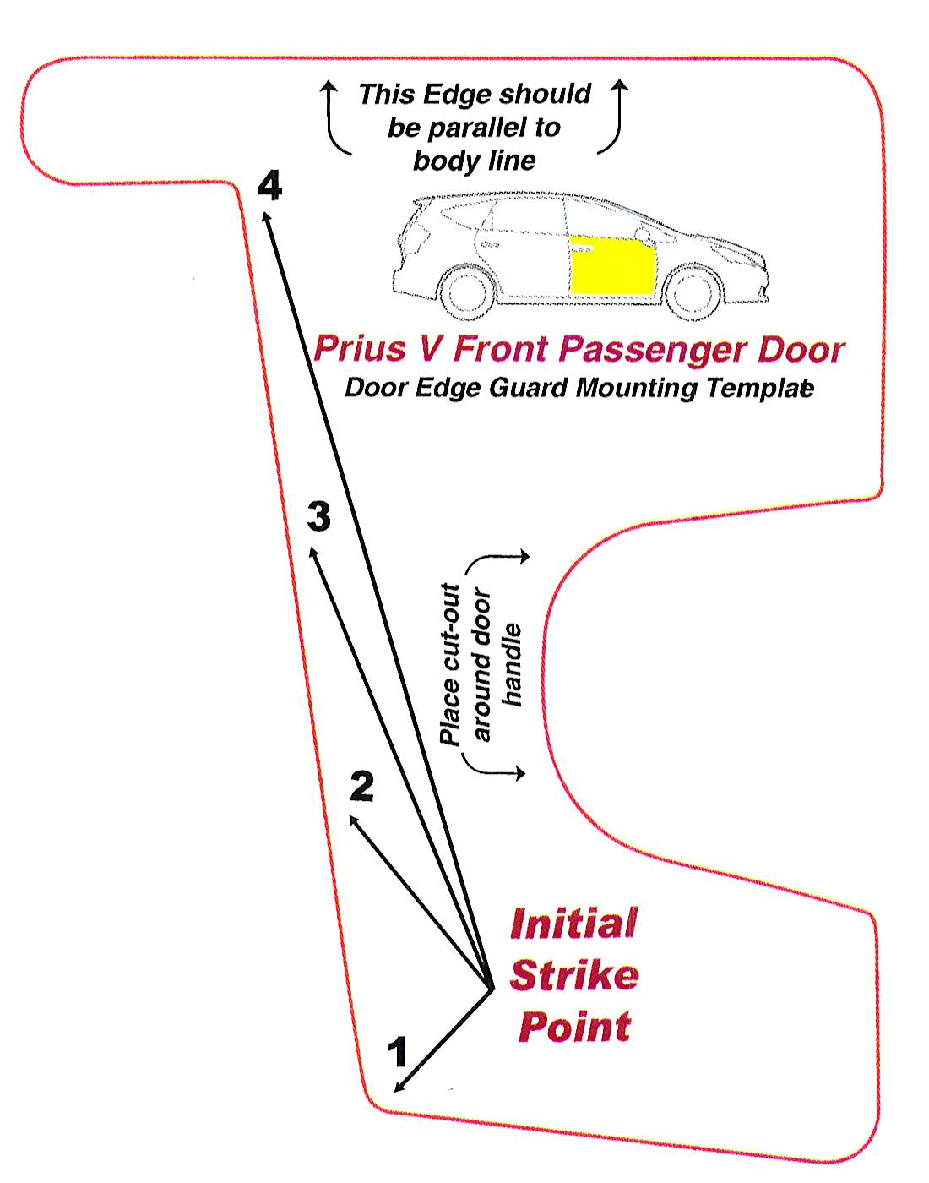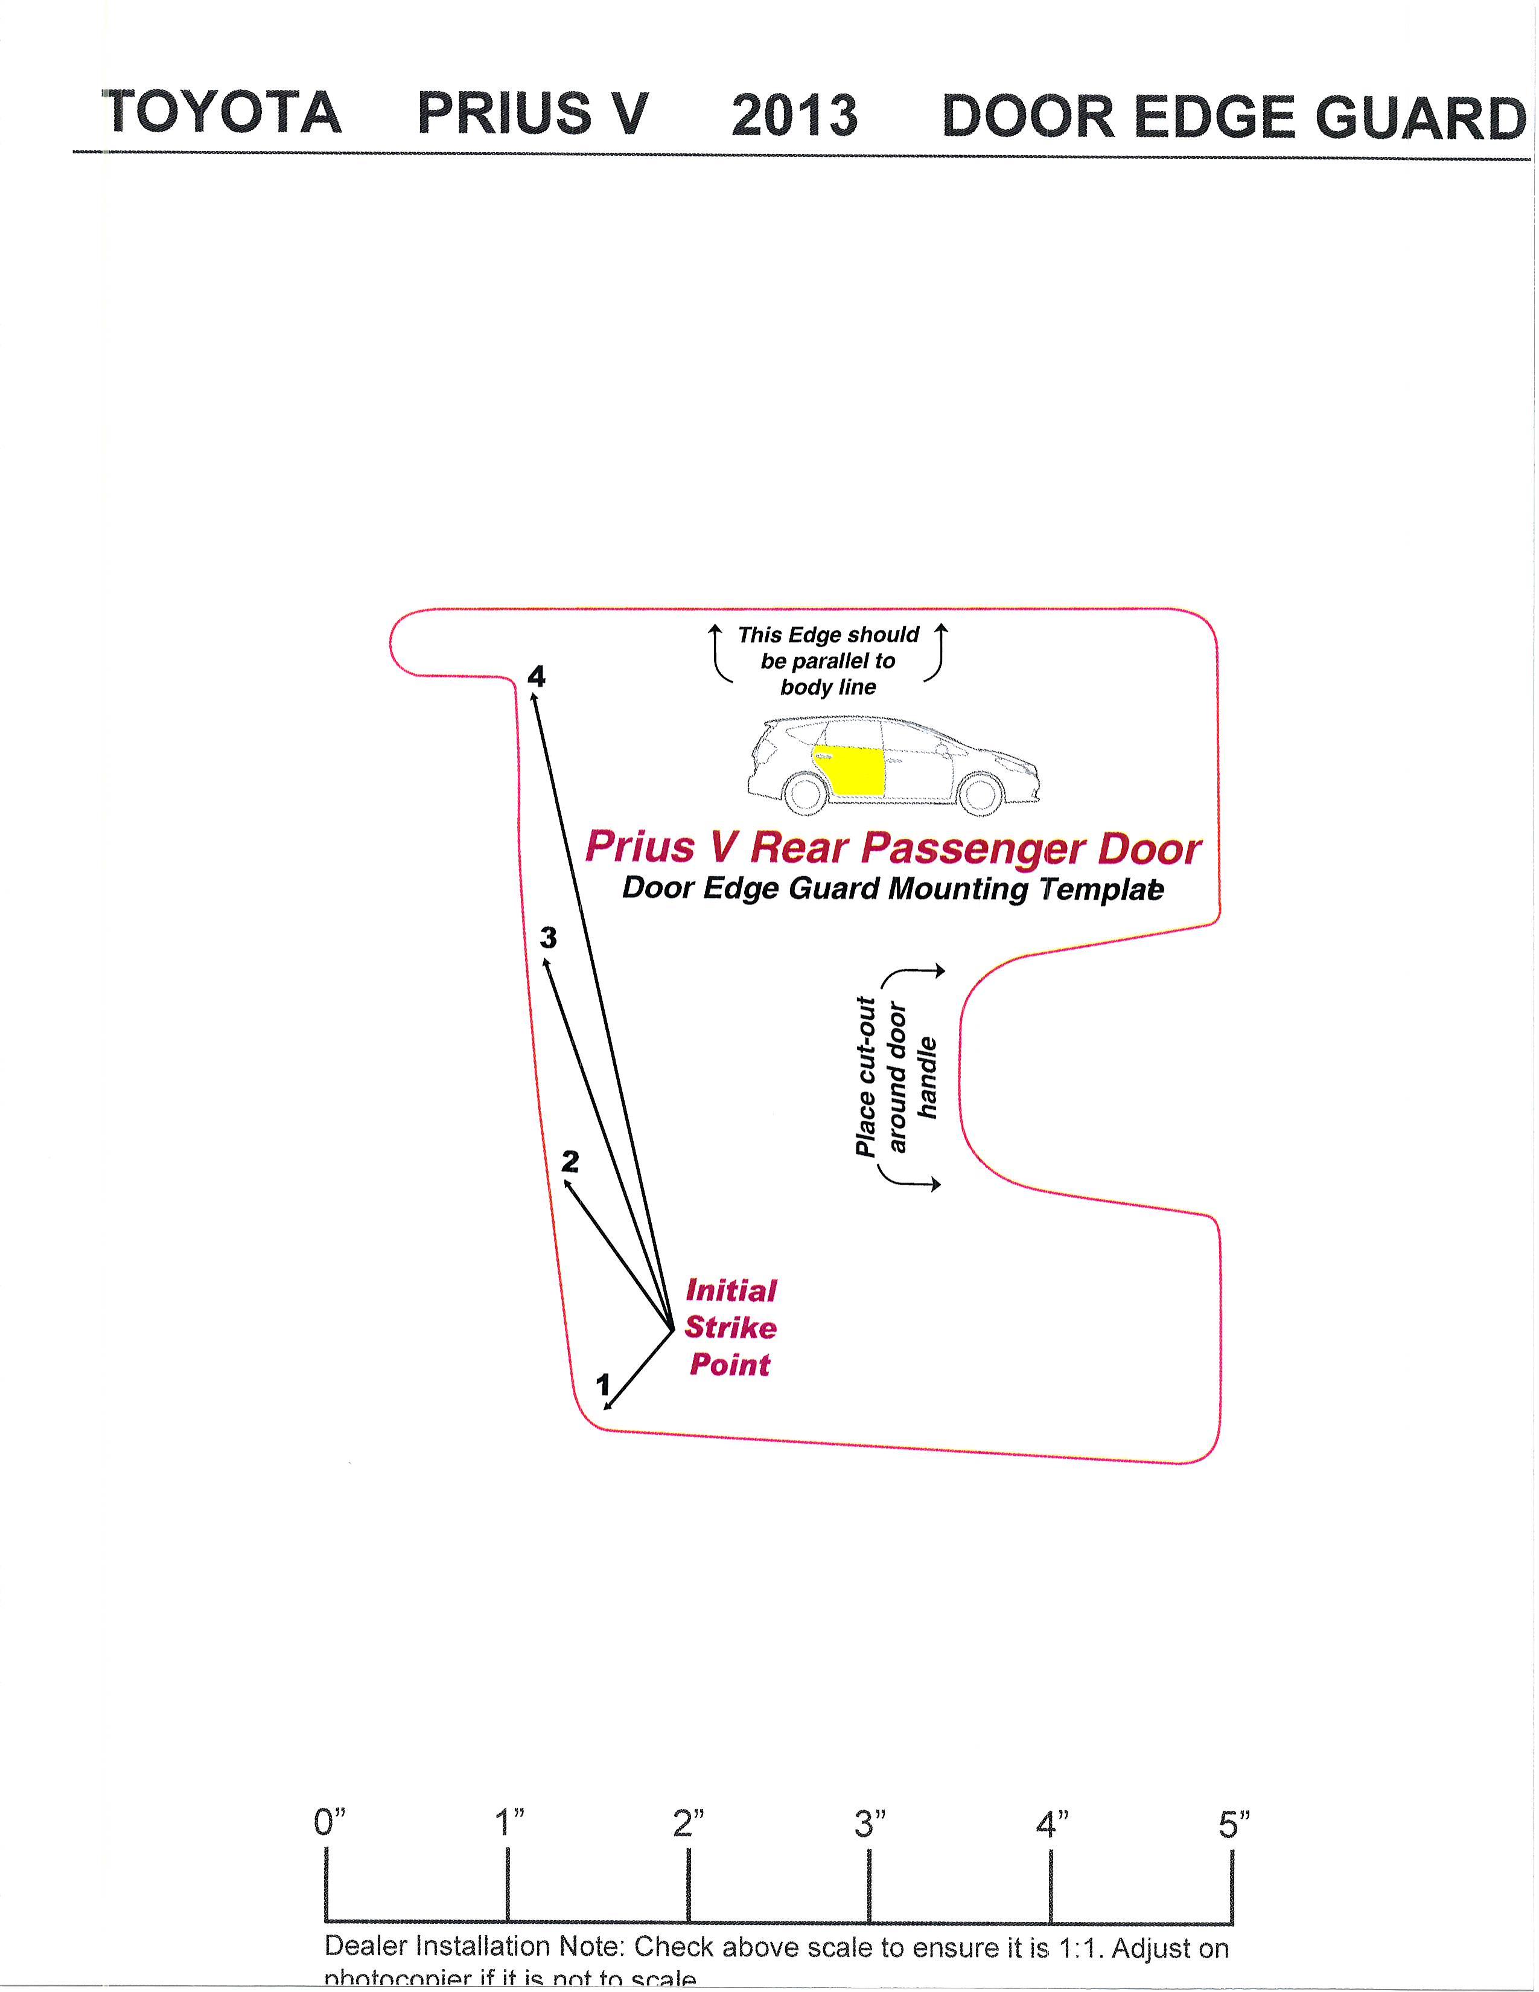
5”
4”
3”
2”
1”
0”
Dealer Installation Note: Check above scale to ensure it is 1:1. Adjust on
photocopier if it is not to scale.

